The Rosie Hood Band

Nicola Beazley  She/her  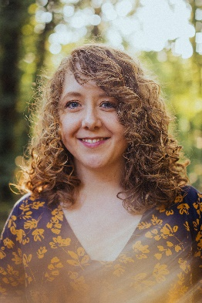 | Rosie Butler-Hall  She/her  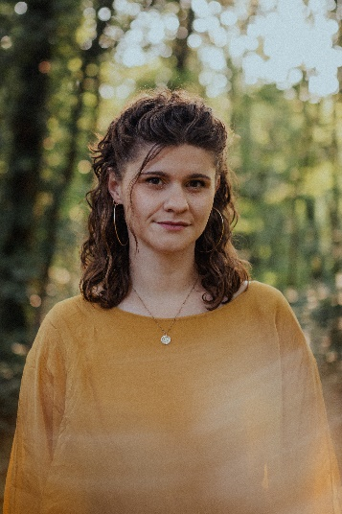 | Rosie Hood  She/her  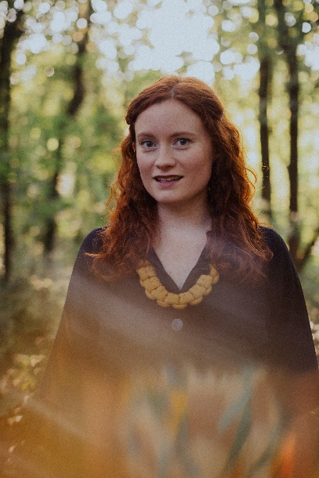 | Robyn Wallace  They/them  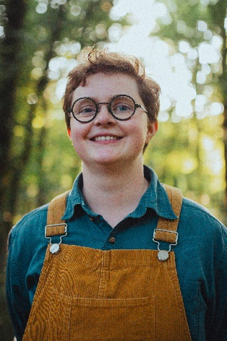

Notes for comperes

Line-up
Rosie Hood – vocals/tenor guitar/baritone ukulele
Nicola Beazley – fiddle/vocals
Robyn Wallace – melodeon
Rosie Butler-Hall – fiddle/vocals

Pronouns
Rosie, Nicola and Rosie BH’s pronouns are she/her
e.g. “She was nominated for the Horizon award…”
Robyn’s pronouns are they/them
e.g. “They play the melodeon…”

Biography
A Horizon Folk Award nominee, Rosie Hood is known for her powerful, clear vocals and captivating performances combining poetic writing with honest interpretations of traditional English songs. In her ‘Classy’ (MOJO) 4-piece, Rosie is joined by fiddle-player Nicola Beazley, melodeon-player & percussionist Robyn Wallace and fiddle-player Rosie Butler-Hall. The instrumentalists bring dynamic lift and drive, expanding Rosie’s vision to re-work traditional songs and bring unheard stories to life. ‘To me, the story is always the most important thing, that’s the ‘Seed Of Gold’ within a song’ explains Rosie. The band released their debut album, Seed of Gold, in November 2023.

Here is some information you could include in your introduction about the Band:

- We released our debut album album, A Seed Of Gold, in November 2023 to favourable reviews:
‘A classy band’ - MOJO Magazine
‘An absolute joy’ – Folk London

- We perform re-workings of traditional English songs as well as original material, touching on politics, struggle, women’s voices and unheard stories

- We all live in Sheffield though originally both Rosies grew up in Wiltshire and Nic and Robyn are from Rochdale

- Rosie was nominated for the Horizon award at the BBC Radio 2 Folk Awards back in 2016

- We have CDs for sale (and can take card payments!)

